1. What are the limitations in selenium WebDriver?

We can’t test the desktop based applications.

We can test mobile applications but we need to use the Appium for that.

We can’t automate the CAPTCHA, Flash, Silverlight Components, Applet Controls, Native window dialogs.

1. Installing/Configure selenium

Step1: First we need to download the eclipse

Step2: Download the selenium Web Driver (Selenium Standalone server jar)

Step3: Download the latest version

Step4: Save the Selenium standalone server jar and link eclipse with selenium.

Step5: Open the eclipse->Create New Project-> Right click on the created Project->Build path->Configure build path-> In java Build path-> Libraries -> Add External JARS->Go to downloads and open Selenium Standalone server jar and click on Okay

1. what are different ways of locating elements in selenium

Selenium WebDriver API supports different possibilities to identify elements: by ID, by CLASS, by NAME, by CSS selector, by XPath, by TAG name. Also you define your custom selector in order to interact with the elements.

The most popular selectors are the CSS selectors due to performance and simplicity reasons.

To inspect an element you just have to open the desired web page, right-click the desired element and click on Inspect Element. A new panel will open showing the desired element. Also you can inspect other elements by clicking on the cursor in the top left side of the Developer Tools or Firebug panels and hovering page elements.

Locating Elements with Selenium WebDriver, findElement() method returns and WebElement and findElements() returns a list of WebElements.

By ID: IN java : driver.findElement(By.id(“element id”))

By CLASS: In Java: driver.findElement(By.ClassName(“element class”))

By NAME: In Java: driver.findElement(By.name(“element name”))

By TAGNAME: In Java: driver.findElement(By.tagName(“element html tag name”))

By CSS Selector: In Java: driver.findElement(By.cssSelector(“css selector”))

By Link: In Java: driver.findElement(By.link(“link text”))

By xPath: In Java: driver.finfElement(By.xpath(“xpath expression”))

1. Which is fastest way to identify elements in web page?

Finding elements by ID is usually going to be the fastest option, because at its root, it eventually calls down to driver.findElement(By.id), which is optimized by many browsers.

1. What is absolute path and relative path in xpath ?

Location path specifies the location of node in XML document. This path can be absolute or relative. If location path starts with root node or with '/' then it is an absolute path. Following are few of the example locating the elements using absolute path.

**/class/student** − select student nodes within class root node.

<xsl:for – each select = ”/class/Student”>

**/class/student/firstname** − select firstname of a student node within class root node.

**<p>**

**<xsl : value of select =”/class/student/firstname”/>**

**</p>**

Relative path in xpath:

For Relative Xpath the path starts from the middle of the HTML DOM structure. Its start with the double forward slash (//), which means it can search the element anywhere at the webpage.

Relative Xpath: //*[@class=’feature –box ]//*[ text ()=’Testing’]

1. Different types of waits or synchronization in selenium webdriver?

Synchronization is Global concept(we can see this in java,oracle,QTP..)

In General:It is a process of coordinating or matching two or more activities/ devices/Processes in time.

Test Automation: Process of matching the speeds of AUT(Application under test) and Test tool in order to get proper execution.

Why Synchronization?(During Test execution time will get Syn problem)

During test execution Test tool gives instructions one by one with same speed,but AUT takes less time for some test execution and more time for some test execution in order to keep them in sync then synchronization is required.

When it is required

Whenever any step requires more than synchronization time for execution there synchronization is required

//Syn time is 30 sec(Perform Dry run(Sample run) then we can identify the synchronization problem)

Types of synchronization: we have 2 types

1. Unconditional Synchronization: In this we specify time out value, We will make the tool to wait certain amount of time and then proceed.(It will wait for max time)

Syntax: Thread.sleep(Time in milli seconds);

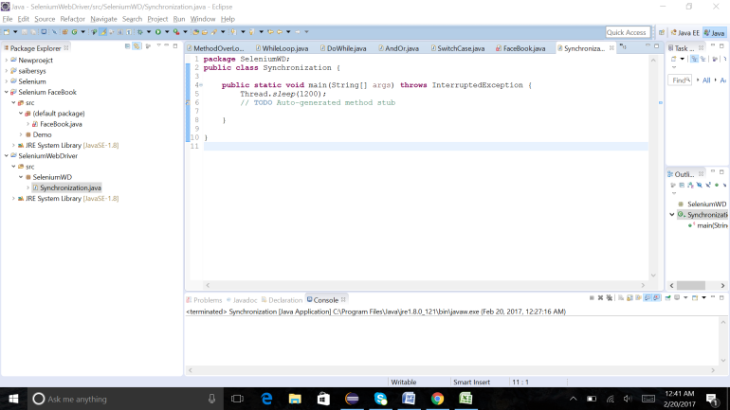

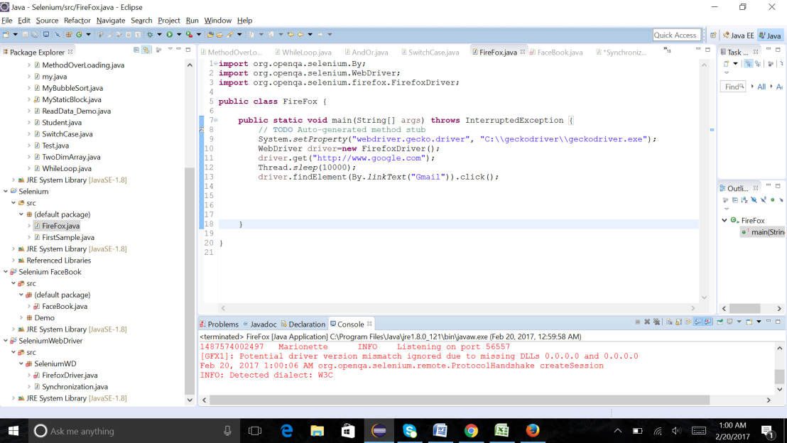

1. Conditional Synchronization(Implicit): (It will wait for required time) it will not work for all commands or statements in the applications.

It works only for findElement and findElements statements

Syntax: Driver().manage().timeouts().implicitlywait(Time in seconds,TimeUnit.SECONDS);

Example:

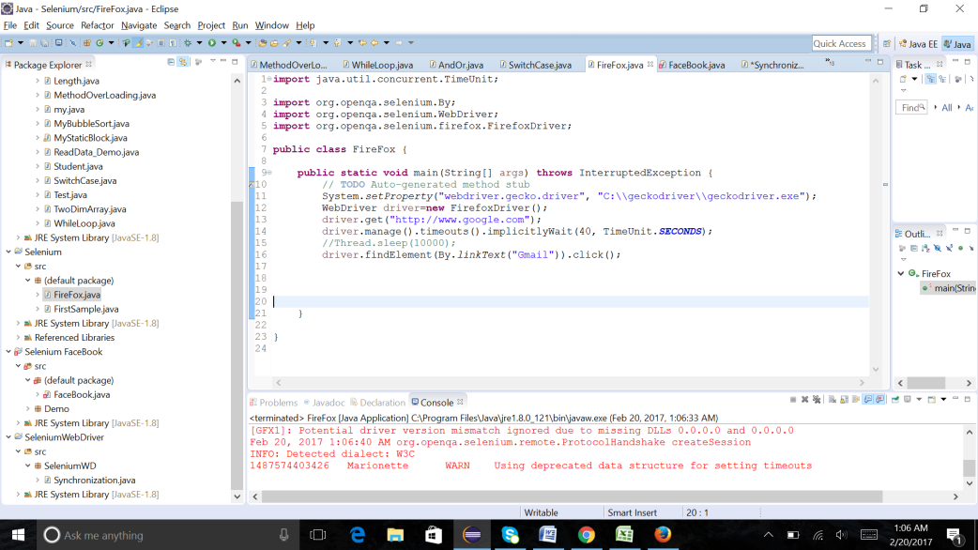

1. How to save screen shots using selenium webdriver?

import java.io.IOException;  
import org.apache.commons.io.FileUtils;  
import org.openqa.selenium.OutputType;  
import org.openqa.selenium.TakesScreenshot;  
import java.io.File;   
import org.openqa.selenium.WebDriver;  
import org.openqa.selenium.chrome.ChromeDriver;  
import org.testng.annotations.Test;  
 public class Screenshot {  
 @Test  
 public void TestJavaS1()  
{             
System.setProperty("webdriver.chrome.driver","C:\\Selenium\\chromedriver.exe");  
WebDriver driver = new ChromeDriver();  
driver.manage().window().maximize();  
driver.get("[http://www.google.com](http://www.google.com/)");  
   
 File src= ((TakesScreenshot)driver).getScreenshotAs(OutputType.FILE);  
try {  
 FileUtils.copyFile(src, new File("C:/Selenium/error.png"));  
}  
 catch (IOException e)  
 {  
  System.out.println(e.getMessage());  
  }  
 }  
 }

1. How to handle multiple windows in selenium webdriver?

import java.util.concurrent.TimeUnit;  
  
import org.openqa.selenium.By;  
import org.openqa.selenium.WebDriver;  
import org.openqa.selenium.chrome.ChromeDriver;  
  
public class Multi {  
public static void main(String[] args) throws InterruptedException {  
     
System.setProperty("webdriver.chrome.driver","C:\\Selenium\\chromedriver.exe");  
WebDriver driver = new ChromeDriver();  
  
   driver.get("[http://seleniumhq.org/](http://www.google.com/url?q=http%3A%2F%2Fseleniumhq.org%2F&sa=D&sntz=1&usg=AFQjCNERCeR4yKwQKkRE2Oqq68zTNpx6aA)");  
   driver.manage().timeouts().implicitlyWait(10, TimeUnit.SECONDS);  
   driver.manage().window().maximize();  
     
   driver.findElement(By.linkText("Documentation")).click();  
   System.out.println(driver.getCurrentUrl());  
   driver.navigate().back();  
   System.out.println(driver.getCurrentUrl());  
   Thread.sleep(30000);  
   driver.navigate().forward();  
   System.out.println("Forward");  
   Thread.sleep(30000);  
   driver.navigate().refresh();  
  
}  
  
}

1. What is desired capabilities in selenium web driver?

**import** org.openqa.selenium.WebDriver;

**import** org.openqa.selenium.ie.InternetExplorerDriver;

**import** org.openqa.selenium.remote.DesiredCapabilities;

**public** **class** UsingDesireCapabilityMethods {

**public** **static** **void** main(String[] args) {

DesiredCapabilities desirecapabilities = DesiredCapabilities.*internetExplorer*();

desirecapabilities.setBrowserName("IE");

desirecapabilities.getBrowserName();

String version =desirecapabilities.getVersion();

System.***out***.println("version of the IE using: "+version);

System.*setProperty*("webdriver.ie.driver","C:\\selenium\\IEDriverServer.exe");

WebDriver driver = **new** InternetExplorerDriver(desirecapabilities);

driver.get("http://Facebook.com/index.php");

}

}

1. how to launch webpage using chrome driver?

**import** org.openqa.selenium.WebDriver;

**import** org.openqa.selenium.chrome.ChromeDriver;

**public** **class** TestChrome {

**public** **static** **void** main(String[] args) {

System.*setProperty*("webdriver.chrome.driver","C:\\Selenium\\chromedriver.exe");

// Initialize browser

WebDriver driver=**new** ChromeDriver();

// Open facebook

driver.get("http://www.facebook.com");

// Maximize browser

driver.manage().window().maximize();

}}

1. How to set language while opening website

**import** org.openqa.selenium.WebDriver;

**import** org.openqa.selenium.firefox.FirefoxDriver;

**import** org.openqa.selenium.firefox.FirefoxProfile;

**public** **class** ChangingLanguage {

**public** **static** **void** main(String[] args) {

//for Firefox

FirefoxProfile fireFoxProfile = **new** FirefoxProfile();

System.*setProperty*("webdriver.gecko.driver", "C:\\geckodriver\\geckodriver.exe");

// setting language to telugu using firefoz profile

fireFoxProfile.setPreference("intl.accept_languages", "te");

WebDriver driver = **new** FirefoxDriver(fireFoxProfile);

driver.get("https://www.Google.com/");

}

}

1. How to handle windows based popups (upload and dropdown)

**import** org.openqa.selenium.By;

**import** org.openqa.selenium.WebDriver;

**import** org.openqa.selenium.firefox.FirefoxDriver;

**import** org.openqa.selenium.support.ui.Select;

**public** **class** DropDownList {

**public** **static** **void** main(String[] args) {

System.*setProperty*("webdriver.gecko.driver", "C:\\geckodriver\\geckodriver.exe");

WebDriver driver = **new** FirefoxDriver();

driver.get("https://www.facebook.com/");

Select month = **new** Select( driver.findElement(By.*id*("month")));

month.selectByVisibleText("Mar");

Select day =**new** Select( driver.findElement(By.*id*("day")));

day.selectByIndex(6);

Select year = **new** Select(driver.findElement(By.*id*("year")));

//note: it is not as same as visible value. get the value of the element using firebug

year.selectByValue("2016");

}

}

1. Write code to verify any application login page is working or not?

**import** org.openqa.selenium.By;

**import** org.openqa.selenium.WebDriver;

**import** org.openqa.selenium.firefox.FirefoxDriver;

**public** **class** VerifyLogin {

**public** **static** **void** main(String[] args) {

System.*setProperty*("webdriver.gecko.driver", "C:\\geckodriver\\geckodriver.exe");

WebDriver driver = **new** FirefoxDriver();

driver.get("https://www.facebook.com/");

driver.findElement(By.*id*("email")).sendKeys("Sudhavani68@yahoo.com");

driver.findElement(By.*id*("pass")).sendKeys("Password");

driver.findElement(By.*id*("u_0_n")).click();

}

}

1. How to select items from dropdown/select box

**import** org.openqa.selenium.By;

**import** org.openqa.selenium.WebDriver;

**import** org.openqa.selenium.firefox.FirefoxDriver;

**import** org.openqa.selenium.support.ui.Select;

**public** **class** DropDownList {

**public** **static** **void** main(String[] args) {

System.*setProperty*("webdriver.gecko.driver", "C:\\geckodriver\\geckodriver.exe");

WebDriver driver = **new** FirefoxDriver();

driver.get("https://www.facebook.com/");

Select month = **new** Select( driver.findElement(By.*id*("month")));

month.selectByVisibleText("Mar");

Select day =**new** Select( driver.findElement(By.*id*("day")));

day.selectByIndex(6);

Select year = **new** Select(driver.findElement(By.*id*("year")));

//note: it is not as same as visible value. get the value of the element using firebug

year.selectByValue("2016");

}

}

1. How to know if checkbox is checked or not in webpage?

**import** org.openqa.selenium.By;

**import** org.openqa.selenium.WebDriver;

**import** org.openqa.selenium.firefox.FirefoxDriver;

**public** **class** CheckBoxChecked {

**public** **static** **void** main(String[] args) {

System.*setProperty*("webdriver.gecko.driver", "C:\\geckodriver\\geckodriver.exe");

WebDriver driver = **new** FirefoxDriver();

driver.get("https://www.gmail.com");

driver.findElement(By.*id*("Email")).sendKeys("sudhavani568@gmail.com");

driver.findElement(By.*id*("next")).click();

// steps to find checkbox checked

**boolean** ischecked;

ischecked = driver.findElement(By.*id*("PersistentCookie")).isSelected();

System.***out***.println(" CheckBox checked? : "+ischecked);

driver.close();

}

}

1. Tell me code to pass values from parent window to child window

**import** java.util.Set;

**import** java.util.concurrent.TimeUnit;

**import** org.openqa.selenium.By;

**import** org.openqa.selenium.WebDriver;

**import** org.openqa.selenium.firefox.FirefoxDriver;

**import** com.gargoylesoftware.htmlunit.javascript.host.Iterator;

**public** **class** Parent{

**public** **static** **void** main(String[] args) {

WebDriver driver = **new** FirefoxDriver();

System.*setProperty*("webdriver.gecko.driver", "C:\\geckodriver\\geckodriver.exe");

driver.manage().timeouts().implicitlyWait(20,TimeUnit.***SECONDS***);

driver.manage().window().maximize();

driver.get("http://www.google.com/");

driver.findElement(By.*xpath*("//*@1d='signipanel']/span/a")).click();

driver.findElement(By.*xpath*("//*@1d='signin']/div[6]/button")).click();

Set<String> set1 = driver.getWindowHandles();

Iterator win1=(Iterator) set1.iterator();

String parent=(String) win1.next();

String child= (String) win1.next();

driver.switchTo().window(child);

}}

1. Write code to find out if all links are working or not

**import** java.io.IOException;

**import** java.net.HttpURLConnection;

**import** java.net.MalformedURLException;

**import** java.net.URL;

**import** java.util.ArrayList;

**import** java.util.List;

**import** org.openqa.selenium.By;

**import** org.openqa.selenium.WebDriver;

**import** org.openqa.selenium.WebElement;

**import** org.openqa.selenium.firefox.FirefoxDriver;

**public** **class** BrokenLinks {

**public** **static** **void** main(String[] args) **throws** IOException {

**int** workingLinks =0;

**int** nonWorkingLinks =0;

System.*setProperty*("webdriver.gecko.driver", "C:\\geckodriver\\geckodriver.exe");

WebDriver driver = **new** FirefoxDriver();

driver.get("http://facebook.com");

//storing all the existing links using tag name "a"

List<WebElement> listOfLinks = driver.findElements(By.*tagName*("a"));

**for**(WebElement e : listOfLinks)

{

//getting the URl and saving in URL class

URL u = **new** URL(e.getAttribute("href"));

//opening each connection

HttpURLConnection urlconnection = (HttpURLConnection)u.openConnection();

urlconnection.connect();

// 200 is the Http response when links work fine

**if**(urlconnection.getResponseCode()==200)

{

workingLinks++; //increasing the count when link works

}

**else**

{

nonWorkingLinks++; //increasing the count when link fails

}

urlconnection.disconnect();

}

System.***out***.println("Total Number of Links: "+listOfLinks.size());

System.***out***.println("No of working links: "+workingLinks);

System.***out***.println("No of non working Links: "+nonWorkingLinks);

driver.close();

}

}

1. Write code on how to use JavaScript executor?

JavascriptExecutor js = (JavascriptExecutor)driver;

Js.executeScript("alert('hello world');");

1. Difference between assert and verify?

**import** org.openqa.selenium.By;

**import** org.openqa.selenium.WebDriver;

**import** org.openqa.selenium.firefox.FirefoxDriver;

**public** **class** AssertVerify {

// assert class can be found in testng and there is no verify in testng

**public** **void** testMethod() {

WebDriver driver = **new** FirefoxDriver();

System.*setProperty*("webdriver.gecko.driver", "C:\\geckodriver\\geckodriver.exe");

driver.get("https://en.wikipedia.org/wiki/Rothschild_family");

String heading= driver.findElement(By.*id*("firstHeading")).getText();

// assert will stop the execution if it fails.

Assert.assertEquals(heading, "Rothschild family");

driver.close();

}

}

1. Difference between driver.close and driver.quit methods?

**import** org.openqa.selenium.By;

**import** org.openqa.selenium.WebDriver;

**import** org.openqa.selenium.firefox.FirefoxDriver;

**public** **class** DriverCloseQuit {

**public** **static** **void** usingClose() {

System.*setProperty*("webdriver.gecko.driver", "C:\\geckodriver\\geckodriver.exe");

WebDriver driver = **new** FirefoxDriver();

driver.get("http://automationpractice.com/index.php");

driver.findElement(By.*xpath*(".//*[@id='social_block']/ul/li[2]/a")).click();

//doesn't close child pages

driver.close();

}

**public** **static** **void** usingQuit(){

System.*setProperty*("webdriver.gecko.driver", "C:\\geckodriver\\geckodriver.exe");

WebDriver driver = **new** FirefoxDriver();

driver.get("http://automationpractice.com/index.php");

driver.findElement(By.*xpath*(".//*[@id='social_block']/ul/li[2]/a")).click();

// closes all the pages

driver.quit();

}

**public** **static** **void** main(String[] args) {

*usingClose*();

*usingQuit*();

}

}

1. Common exceptions in selenium?

**import** org.openqa.selenium.By;

**import** org.openqa.selenium.NoSuchElementException;

**import** org.openqa.selenium.WebDriver;

**import** org.openqa.selenium.firefox.FirefoxDriver;

**public** **class** ExceptionInSelenium {

**public** **static** **void** main(String[] args) {

System.*setProperty*("webdriver.gecko.driver", "C:\\geckodriver\\geckodriver.exe");

/*They are many execptions in selenium and can be caught using try catch block

* all the exceptions can be caught using catch(exeception e) below is an example of NoSuchElementException

* */

WebDriver driver = **new** FirefoxDriver();

driver.get("http://automationpractice.com/index.php");

**try**{ // actual id = search_query_top

driver.findElement(By.*id*("query_top")).sendKeys("this will not work");

}

**catch**(NoSuchElementException e)

{

System.***out***.println( "execption found and caught. This way it will not stop the execution of the program");

}

driver.close();

}

}

1. How to handle Ajax calls in selenium?
2. We have webtable, need to click on second row from table.
3. When we click on child will be populated. first column in primary column for each row.
4. Tell me steps to verify child form has proper data or not
5. How to assign the value to textbox other than sendkeys method?
6. Selenium grid, how to execute scripts on multiple browser
7. Write code for drag/drop in selenium

**import** java.util.concurrent.TimeUnit;

**import** org.openqa.selenium.By;

**import** org.openqa.selenium.WebDriver;

**import** org.openqa.selenium.WebElement;

**import** org.openqa.selenium.firefox.FirefoxDriver;

**import** org.openqa.selenium.interactions.Action;

**import** org.openqa.selenium.interactions.Actions;

**public** **class** DragAndDrop {

**public** **static** **void** main(String[] args) **throws** InterruptedException {

System.*setProperty*("webdriver.gecko.driver", "C:\\geckodriver\\geckodriver.exe");

WebDriver driver = **new** FirefoxDriver();

driver.get("http://only-testing-blog.blogspot.in/2014/09/drag-and-drop.html");

Actions action = **new** Actions(driver);

action.dragAndDrop(driver.findElement(By.*id*("dragdiv")), driver.findElement(By.*id*("dropdiv")));

action.perform();

}

}

1. Write code for right click in selenium

**import** org.openqa.selenium.By;

**import** org.openqa.selenium.WebDriver;

**import** org.openqa.selenium.firefox.FirefoxDriver;

**import** org.openqa.selenium.interactions.Actions;

**public** **class** RightClick {

**public** **static** **void** main(String[] args) {

System.*setProperty*("webdriver.gecko.driver", "C:\\geckodriver\\geckodriver.exe");

WebDriver driver = **new** FirefoxDriver();

driver.get("http:www.facebook.com");

Actions action = **new** Actions(driver);

action.contextClick(driver.findElement(By.*xpath*(".//*[@id='content']/div/div/div")));

action.perform();

}

}

1. Write code for scroll to specific element